SRS for quickship – logistic management platform
1. Actors
Actor | Description
Admin | Warehouse managers or coordinators. Have the right to create orders, manage drivers, and monitor the entire system.
Driver | Delivery drivers. Use your mobile device to receive your application, update your status, and take a confirmation photo.
Customer | Customer (Receiver/Sender). No need to log in, just access to look up orders.

2. Use Case Diagram
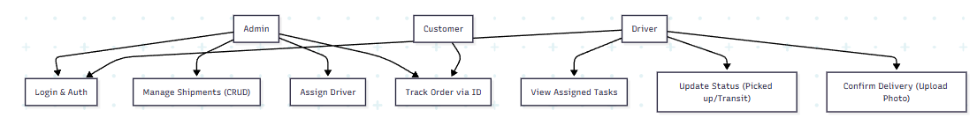
3. Detailed Function Specification
3.1. Admin Module (Admin Dashboard)
Function: Create Shipment
- Description: The admin enters new order information into the system.
- Input data: Customer name, Phone number, Shipping address, Notes (if any).
- Processing Flow:
1. Admin click "Create Menu".
2. The system checks the validity of the data.
3. The system generates a unique Tracking ID (e.g. QS260101).
4. Save to the database with the default status of Pending (Pending).
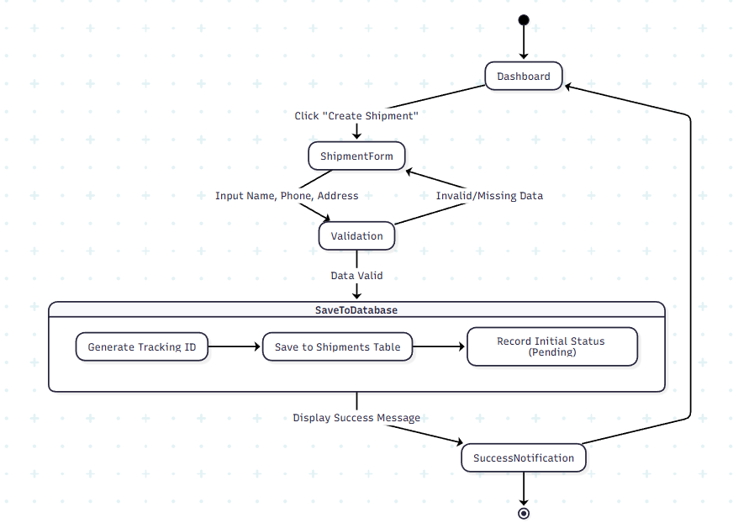
Function: Dispatching & Assigning Drivers
- Description: The admin assigns a specific driver who is responsible for delivering the order.
- Processing Flow:
1. Admin select the order from the list.
2. Select the driver from the drop-down list.
3. The system updates the driver_id for that order.
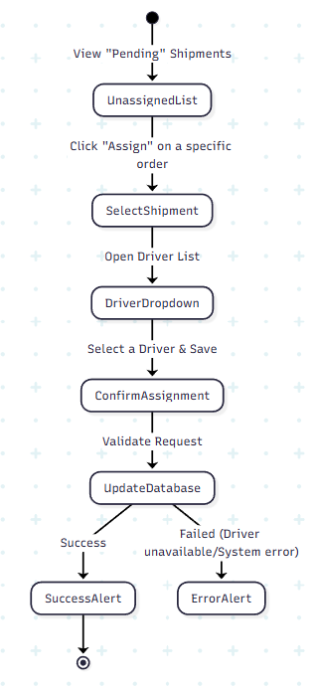
3.2. Module Tài xế (Driver Web-view)
Function: Task List Management
- Description: The driver views the orders he or she has been delivered.
- Eligibility: The driver has logged in to the system via phone.
- Processing flow: The system filters in the database the orders that have the same driver_id as the ID of the driver who is logged in and have a different status than Delivered.
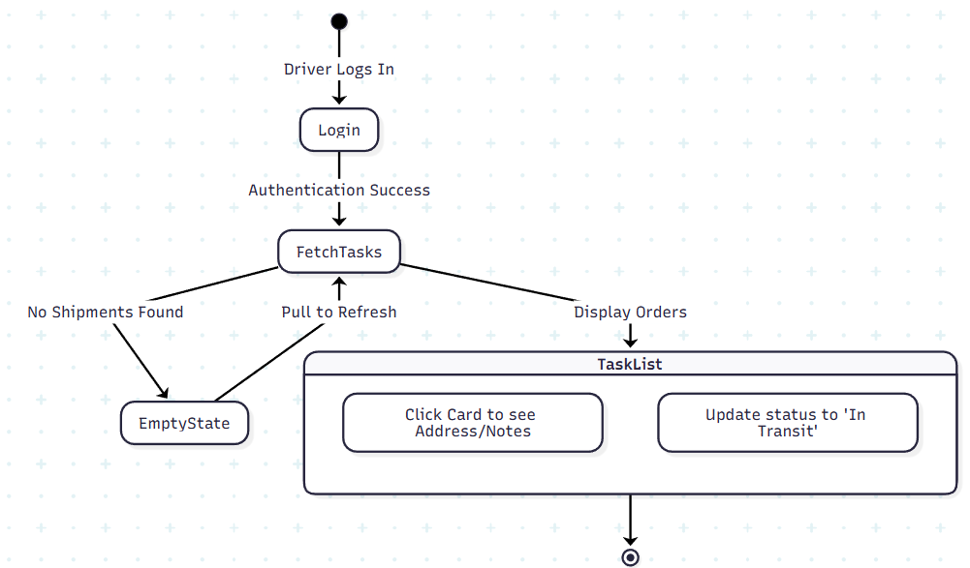
Function: Status Update & PoD
- Description: Change the order lifecycle.
- Function Buttons:
  - Start Delivery: Switches the status to In Transit.
  - Confirm Delivered:
1. The system requires Camera access.
2. The driver takes a photo of the package.
3. The system saves the photos to Storage and switches the status to Delivered.
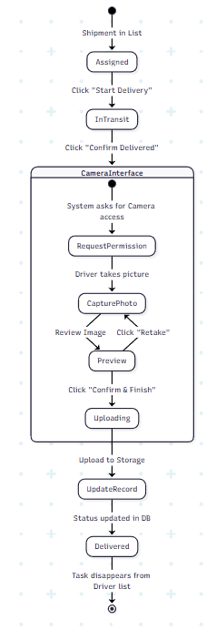

3.3. Module Tra cứu (Public Tracking)
Function: Track Shipment
- Description: Customer checks order status.
- Input data: Tracking ID.
- Processing Flow:
1. The user enters the code.
2. Corresponding order search system.
3. Information Display: Current Status, Last Update Time, and Confirmation Photo (if delivered).
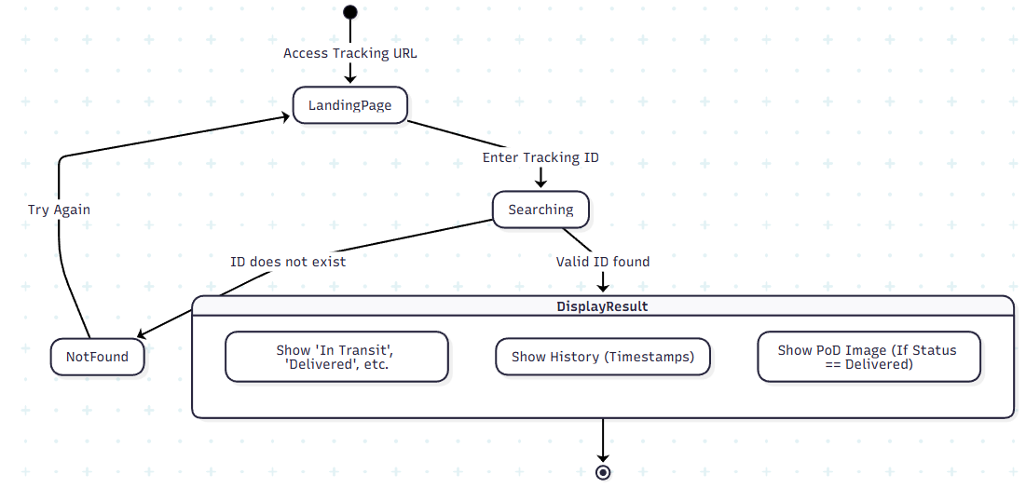
4. Non-functional Requirements
- Usability: The Driver's interface must have a large button, easy to operate with one hand on the phone.
- Performance: The response time when updating the status is no more than 2 seconds.
- Security: * Drivers do not have the right to delete orders or view other drivers' orders.
  - Customers can only view order information when they have the correct Tracking ID.

5. Access Control Matrix
Function | Admin | Driver | Customer
Create/Delete Orders | x
Assign a driver | x
View all orders | x
View assigned orders |  | x
Single Status Updates |  | x
Tracking ID Lookup | x | x | x

